Tai Ji Dog
By
Daniel Loney

My son and his wife own a dog named Boofy, part jack russell and part amstaff. Or anyway, they think that they own him. But, I'm not sure. I think that perhaps Boofy owns them. Boofy is one of those overly coddled dogs, spoiled and not much good for anything practical. In my book, everyone in the family has to pull their own weight; make some sort of positive contribution to the family. I didn't see that Boofy was pulling his weight. In fact, he was just plain worthless; sucking resources out of the family. He had to be fed, walked several times a day, bathed from time-to-time, and seemed to whine constantly when he didn't get his way. You can't even sit down and eat your meal peacefully without paying the "dog tax" by throwing him some of the food off of your plate in order to get him to shut up.

My son and his wife are in the process of relocating from Israel to New York for a number of years. During this transition period they had to vacate their apartment early, so they moved in with us for a number of months. Normally, this wouldn't be any burden on my wife and I, as they both keep busy with their work, help clean and cook, and are really kind of nice to have around. But that Boofy, he's a different story!

Shortly after moving in with us, my daughter-in-law had to travel to New York on a business trip for a couple of weeks, coinciding with my son's call up to do army reserve duty. So, guess who got stuck with Boofy? This meant additional chores and wasting time taking care of the dog, added to an already busy schedule for my wife and I. I remember the first night that Boofy spent with us after my son and his wife had left. Boofy refused to sleep alone in the living room. He whined and whined. So, my wife moved his pillow into our bedroom, next to our bed so that he would have some company at night. Later, I woke up in the middle of the night and felt this lump down by my feet as I tried to turn over. Realizing it was Boofy and that he had relocated himself to our bed while we slept, I muttered "damn dog," and nodded back off to dream land.

Still later, I was awaken again, noticing the migration of the lump from the foot of the bed to the middle. He was now curled up and laying right in the middle of the bed, between my wife and myself. Once again, I marveled at the chutzpa of this animal and managed to fall back off to sleep. Then, a bit later, I was awakened one more time with the feeling that something was sharing my pillow with me. To my amazement, that damn dog was sleeping on my pillow, with his butt right in my face. Enough! Enough! I wacked him a good one, chased him off the bed, only to have the entire migration process restart once again. After several nights of interrupted sleep, we realized that things had to change. We could not continue like this. Now Boofy is quite an intelligent critter. Really, he is very cooperative when you lay down the law, quick to please. It wasn't long until we had him sleeping in his place, obeying the rules of the house.

Boofy had one other trait that bothered me. He was a coward. When taking him for a walk, he would slink between the cats as we passed the garbage receptacles, crouching low in shame and giving them a wide birth. And, while letting him run loose in the park, if another dog growled at him, or heaven forbid began to attack him, Boofy would shoot out of there fast as a rocket. Yes, he was a coward.

However, the relationship began to change between Boofy and myself as I got to know him better. I believe that we humans can learn a lot from animals if we watch them closely. And Boofy became quite a good teacher. In our daily walks to the park, I saw that Boofy was built to run. Yes, Boofy was a runner. Sleek and streamlined, he could out run any dog in the park. I began to notice that if another dog was showing intentions of an oncoming attack, that Boofy used running to his advantage. He subscribed to the Chinese proverb, of the 36 ways to escape, the best is simply to turn and run away. But, to run away like a coward is not what Boofy was doing as I had originally assumed. Boofy was a superb strategist in the art of war. He would use his speed to his advantage. As the attacking dog would chase him, Boofy would run in circles, leaping over boulders and fallen tree trunks, quickly tiring out his enemy. It wasn't long until the attacking dog would tire, loose interest in the pursuit , and give up in desperation. Boofy literally ran the will to fight right out of his opponent.

Another lesson I learned from Boofy was the art of attack. Once as we were returning to our apartment building, we entered the lobby and a large labrador retriever was on his way out of the building with his owner, unleashed, trailing behind. Notice that I said that the owner was unleashed. The labrador went completely berserk, barking and quickly advancing on poor little Boofy. This labrador was at least twice the size of Boofy, and three times Boofy's weight. Boofy had no room to maneuver in the lobby and was quickly cornered by this raving maniac of a dog, growling, teeth exposed ready to tear Boofy to shreds. Then, to my complete surprise, Boofy sunk low, low, and lower, into a perfect tai ji stance, head raised and lips curled bearing his razor sharp teeth. Boofy was crouched low, below his oncoming attacker, drawing his opponent in, poised for what would be a perfectly executed lunge at the bigger dogs throat. His lumbering attacker had no chance; completely outmatched by the smaller dog. Suddenly, at the last moment, just before Boofy was about to launch his attack, the labrador's owner managed to grab his dog and jerk him back. The owner assumed that his bigger dog had won the fight because his dog was after all bigger and attacking from the top, descending on poor little Boofy. What does he or his dog know about tai ji and the art of war? Boofy had come within a split second of ripping that pure bred's throat clean out. That bigger dog is damn lucky that his owner saved him just in time.

I now see Boofy in a whole new light. He is a real Tai Ji dog and an excellent warrior. I'm proud of him! Don't mess with the Boof!

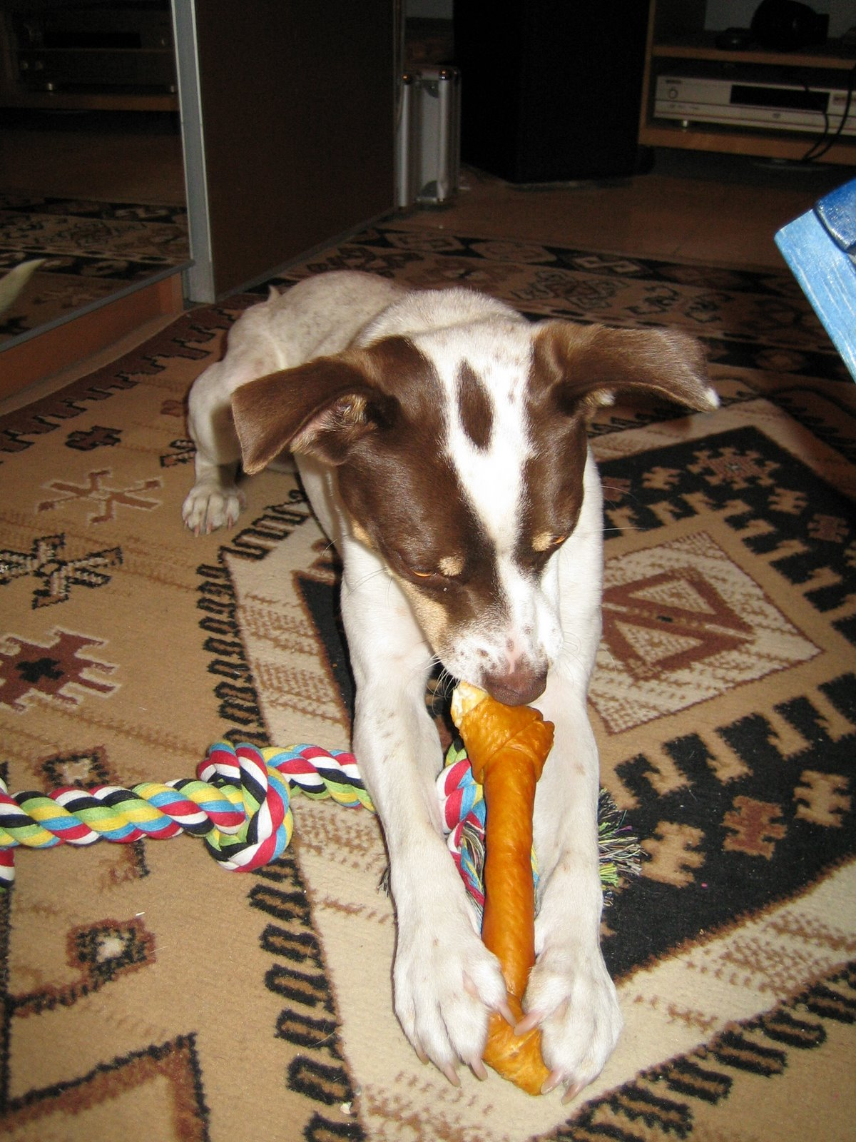
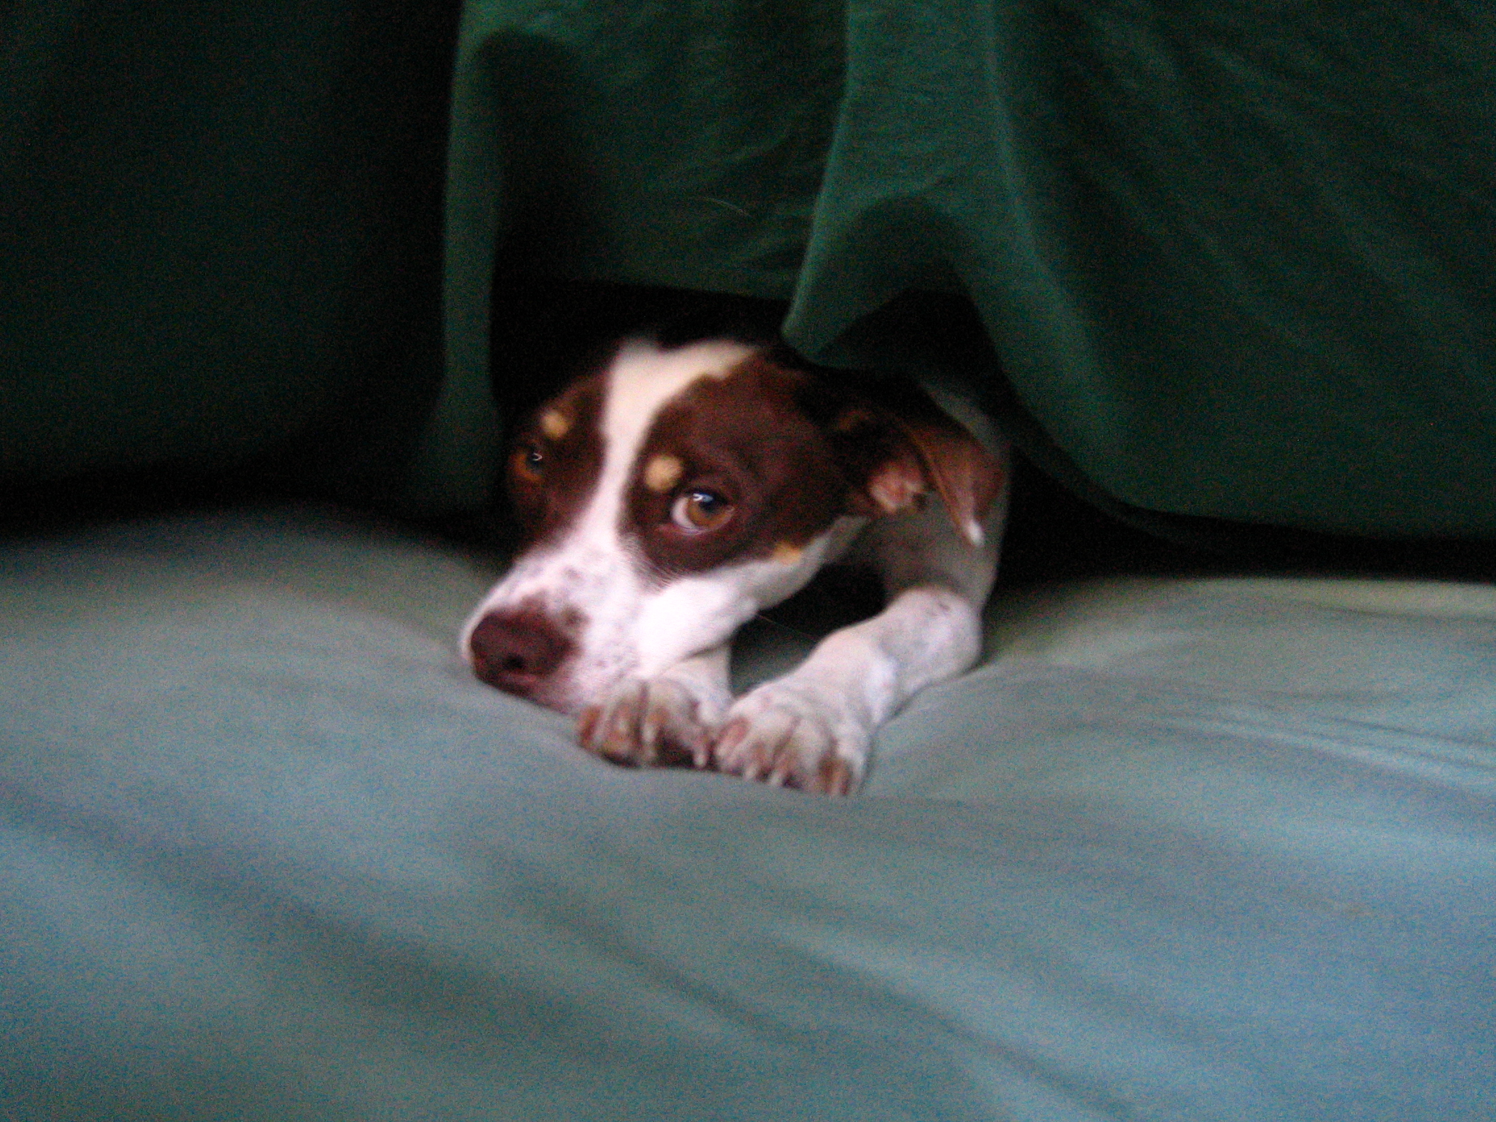
Boofy, resting between battles
Boofy sharpening his teeth

